| **LAB ASSIGNMENT # 01** |
| --- |

**Introduction to Flowcharts and Java Programming**



**CSE110 | Programming Language I**

|  | **LAB TASKS** | **HOME TASKS** |
| --- | --- | --- |
| **CODING** | **06** | **05** |
| **FLOWCHART** | **04** | **05** |

**NOTE: You need to submit only the Home Tasks. Submit all the Flowchart or Tracing tasks hand drawn or handwritten respectively to your Lab Instructors before the next lab. Submit all the Homework Coding Tasks in the Google Form shared on buX.**

**LAB TASKS**

**[NO NEED TO SUBMIT]**

**FLOWCHART TASKS**

**Question: 1**

Design a flowchart to take a number as input, store it in a variable, and print its cube.

**Question: 2**

Create a flowchart to convert a temperature in Fahrenheit to Celsius. The user should input the temperature in Fahrenheit, and the flowchart should display the corresponding temperature in Celsius. The formula to convert Fahrenheit to Celsius is: **C = (F - 32) × 5/9**

**Question: 3**

Jamal is struggling with his math homework, which requires him to calculate the volume of water needed to fill a cylinder completely. Unable to solve the problem on his own, he turns to you, his friend who excels in mathematics and computer science. To assist him, you decide to create a flowchart that takes the cylinder's height (H), radius (R), and the current height of water (h) as user inputs and determines the additional volume of water needed to fill the cylinder to its full capacity.

**[ Volume of Cylinder = $π *R^{2} * H$]**

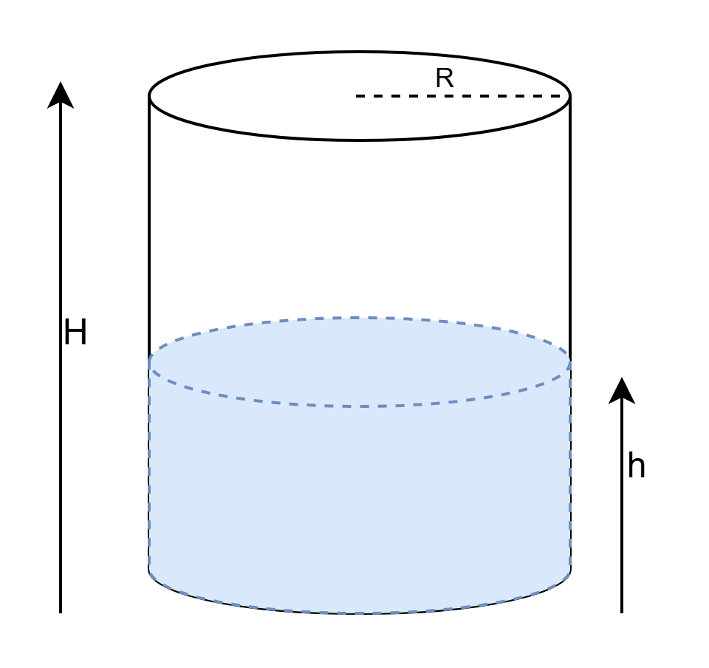

**Fig. 1**

**Question: 4**

Create a flowchart to find the average of three numbers. The flowchart should take three inputs from the user and display their average.

For this course, we’ll be using **DrJava** as IDE for Java Coding:

[**Link to JDK and DrJava**](https://drive.google.com/drive/folders/1pzTIouwS9-tHVEb9HdBnp1WL7NDrK_BI)

**DrJava Installation Guide:**

[**Windows Installation**](https://www.youtube.com/watch?v=Gss9sL3Q-8s)

[**MAC Installation**](https://drive.google.com/drive/folders/1rLjXOiFGHE45nWq4KDQlLwwW55bDhOeQ)

**CODING TASKS**

**Question: 1**

Find out which of the following are legal identifiers in Java, and which are not. Also, explain why the invalid ones are invalid. You can try to define each of these (items a to k below) as a variable in the Dr java interaction pane and find out.

The first one is done for you as an Example. If you want to define hungry, you have to try

**int hungry;**

| 1. **hungry** | 1. **2AB** | 1. **312.2** | 1. **MOBILE** |
| --- | --- | --- | --- |
| 1. **“Ans”** | 1. **$30** | 1. **Yes/No** | 1. **student-id** |
| 1. **A+3** | 1. **‘X’** | 1. **public** | 1. **student_id** |

**Question: 2**

Write the Java code for the following:

1. Declare an **integer** variable. Initialize it with some value of your choice and print it to check the value has been stored properly.
2. Declare and initialize another **integer** variable. Add this to the first one and print out the result. Verify that the addition has been done correctly.
3. Now print the product and division of the two **integer** numbers.
4. Repeat exercises 2.1, 2.2, and 2.3 for variables of data type **double**. Verify your answers.
5. Repeat exercises 2.1, 2.2, and 2.3 for one **double** data type and one **integer** datatype. Verify your answers.
6. Repeat exercises 2.1 and 2.2 for variables of data type **String**. How does the addition operator work for Strings? What if the first variable is an integer and the second is a String and vice versa?

**Question: 3**

Write Java that calculates and prints the circumference and area of a circle with a radius of 4 units. [Hint: use Math.PI to get the value of π]

**Question: 4**

Write a Java code where given an integer, we need to print the last 2 digits of that number.

**Question: 5**

A local tailor named Jamal often receives measurement details from his foreign customers in inches, but his measuring tools only use meters. To make his work easier, Jamal decides to ask his programmer friend (you) to write a simple Java program that will convert inches into meters.

**[ NOTE: 1 inch = 0.0254 meters ]**

**Test Data:**

Given a value for inch: 1000

**Expected Output:**

1000 inch is 25.4 meters

**Question: 6**

Write a Java program declaring two integer variables and initializing them. Your task is to swap the values of these two variables. You must complete it using two different approaches.

* 1. By creating a third variable.
  2. Without creating any other variables.

**Home TASKS**

**FLOWCHART TASKS**

**Question: 1**

Design a flowchart to take an integer consisting of 4 digits as input and print the last 2 digits of that number.

**Question: 2**

Design a flowchart to take an integer consisting of 4 digits as input and print the first 2 digits of that number.

**Question: 3**

Design a flowchart to take three integers a, n, d as input where a is the first term of an arithmetic sequence, **n** is the number of terms and **d** is the common difference between the terms in the sequence, and print the **n-th** term of the arithmetic sequence.

**Question: 4**

Design a flowchart to take two numbers a and c as input (look at the image below), and print the area of the portion colored in green. In the following image, a is the radius of the circle, and c is the length of the sides of the square.

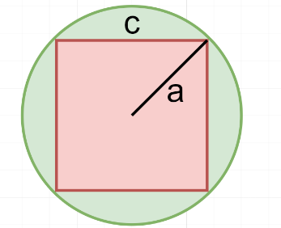

**Fig. 2**

**Question: 5**

Design a flowchart to take a number a as input (look at the image below), and print the area of the portion colored in red. In the following image, a is the diameter of the circle.

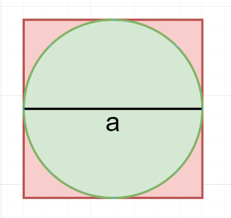

**Fig. 3**

**CODING TASKS**

**Question: 1**

NASA has recently shared the total time (in minutes) since one of its space missions was launched. As a software engineer working at the mission control center, your task is to help them calculate how many years and days have passed since the launch. Therefore, write a Java program that can do the conversion.

**NOTE:** For simplicity, assume each year has exactly **365 days**.

**Test Data:**

Given the number of minutes: 3456789

**Expected Output:**

3456789 minutes is approximately 6 years and 210 days

**Question: 2**

Suppose, you have three integer variables: a, b, c. Your first task is to assign the values 2, 5, 8 in these three variables. Next, you need to calculate and display the value of variable d using the following formula:



Write a Java program based on this mentioned scenario that prints the value of d after calculation. ***[Answer: 27]***

**Question: 3**

Rafi has just started learning Java programming. His teacher gives him a simple challenge to test his understanding of integer manipulation and modulus operations.

The task is to display the two rightmost digits of his student ID in reverse order.

Rafi knows his student ID is **1000054943**, and he must write a Java program that prints the digits **3** and then **4**, since those are the two rightmost digits reversed.

**Question: 4**

Rafi is helping his friend place a Wi-Fi router in a rectangular room. He wants to know the shortest straight-line distance (diagonal) between two opposite corners of the room so that the Wi-Fi signal can reach the farthest corner efficiently. Write a Java program to calculate the diagonal distance using Pythagoras’ Theorem, you can assume the length and width of the room is 10 and 13 respectively.

**Question: 5**

Design a Java program to calculate Sin and Cos values from a right-angled triangle.

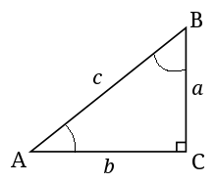

Assume the values of a and b are 4.5 and 9.5 respectively. Finally, print the Sin and Cos values of angle A and angle B (SinA, CosA, SinB, CosB). The formulas to calculate these values are given below.

**Hint:** You need the values for all 3 sides to calculate both sin and cos. You are given only a and b. How would you get the value of c? You’ll need the help of Math.sqrt().

